**OPERATING SYSTEM LAB 2**

**S ABHISHEK**

**AM.EN.U4CSE19147**

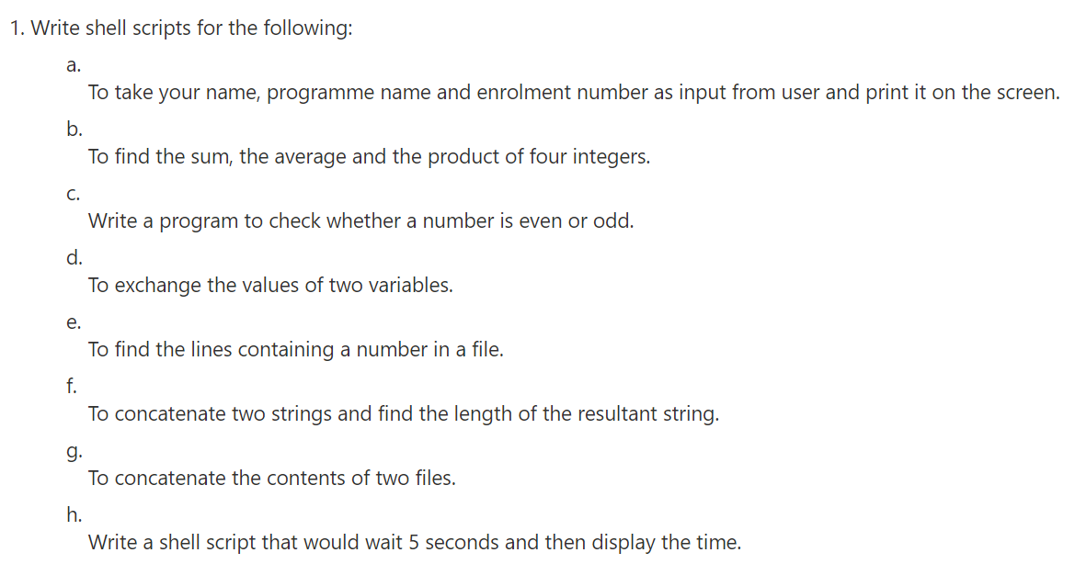

**#!/bin/bash**

**echo "Name and Details : "**

**read -p "Enter Your Name : " varname1**

**read -p "Enter the Program Name : " varname2**

**read -p "Enter the Enrolment Number : " varname3**

**echo Hello $varname1**

**echo Program Name : $varname2**

**echo Enrolment Number : $varname3**

**###############################################**

**num1=0**

**num2=0**

**num3=0**

**num4=0**

**ave=0**

**read -p "Enter the first number : " num1**

**read -p "Enter the second number : " num2**

**read -p "Enter the third number : " num3**

**read -p "Enter the fourth number : " num4**

**echo "Sum = $((num1 + num2 + num3 + num4))"**

**echo "Product = $((num1 * num2 * num3 * num4))"**

**ave=$(echo "scale=2;($num1 + $num2 + $num3 + $num4)/4"| bc)**

**echo "Average = "$ave**

**###############################################**

**echo "Odd or Even : "**

**num1=0**

**read -p "Enter the Number : " num1**

**if [ $((num1 % 2)) == 0 ]**

**then**

**echo "This is Even"**

**else**

**echo "This is Odd"**

**fi**

**###############################################**

**echo "Swap Inputs : "**

**read -p "Enter the Input 1 : " num1**

**read -p "Enter the Input 2 : " num2**

**echo "Before Swapping : "**

**echo "Input 1 = "$num1**

**echo "Input 2 = "$num2**

**temp=$num1**

**num1=$num2**

**num2=$temp**

**echo "After Swapping : "**

**echo "Input 1 = "$num1**

**echo "Input 2 = "$num2**

**################################################**

**echo "Find the Line with Numbers in it : "**

**read -p "Enter the File Name : " file**

**grep [0-9] $file**

**#################################################**

**echo "Concatenate Two Inputs And find its Length : "**

**read -p "Enter the Input 1 : " num1**

**read -p "Enter the Input 2 : " num2**

**echo "Input 1 = "$num1**

**echo "Input 2 = "$num2**

**num3="$num1$num2"**

**echo "Output = "$num3**

**size=${#num3}**

**echo "Length of the Output = "$size**

**#################################################**

**echo "Concatenate File Contents : "**

**read -p "Enter the File 1 : " num1**

**read -p "Enter the File 2 : " num2**

**cat $num1 > out**

**cat $num2 >> out**

**cat out**

**#################################################**

**echo "Sleep for 5 Seconds and Display the Time : "**

**sleep 5**

**date +"%r"**

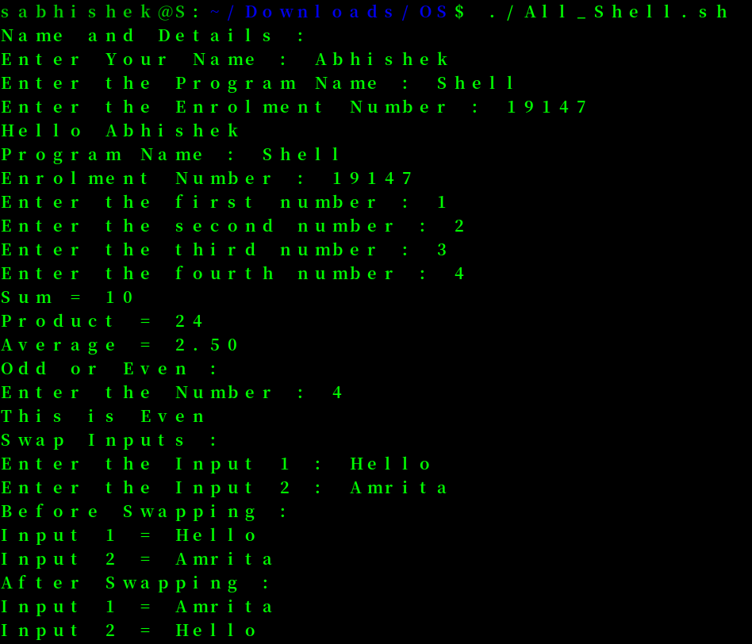

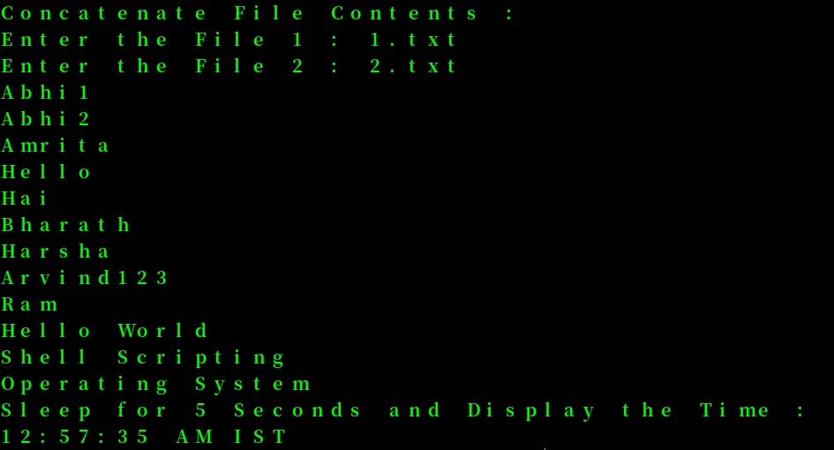

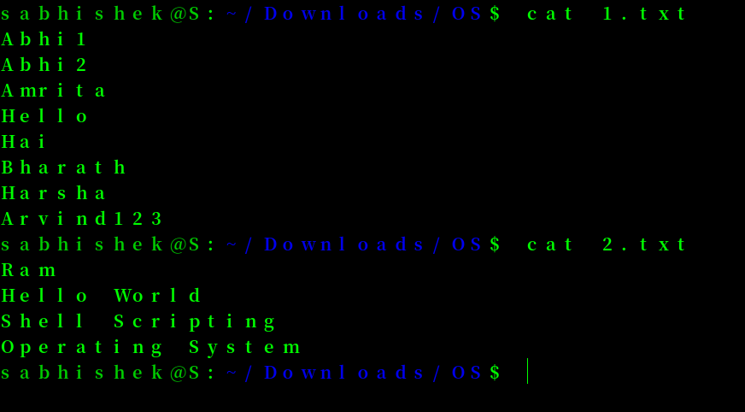

**2. The length and breadth of a rectangle and radius of a circle are provided as user input.**

**Write a shell script that will calculate the area and perimeter of the rectangle and the area and circumference of the circle.**

**Hint: -**

**Area of Rectangle = L*B**

**Perimeter of Rectangle = 2(L+B)**

**Area of Circle = π.r2**

**Circumference of circle = 2. π.r**

#!/bin/bash

len=0.0

bre=0.0

rad=0.0

read -p "Enter the Length of the Rectangle : " len

read -p "Enter the Breadth of the Rectangle : " bre

read -p "Enter the Radius of the Circle : " rad

echo "Area of Rectangle : "$((len*bre))

echo "Perimeter of Rectangle : "$((2*(len+bre)))

area=$(echo "scale=2;3.14 * $rad * $rad" | bc)

peri=$(echo "scale=2;2 * $rad * 3.14"|bc)

echo "Area of circle : " $area

echo "Perimeter of circle : " $peri

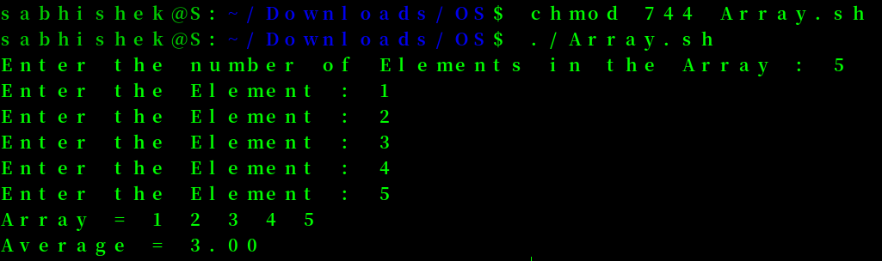

**3. Write a menu driven shell program to read two numbers and print the results of all the arithmetic operations.**

**( + , - , * , / , % , ++ , -- )**

#!/bin/bash

len=0.0

bre=0.0

rad=0.0

read -p "Enter the Length of the Rectangle : " len

read -p "Enter the Breadth of the Rectangle : " bre

read -p "Enter the Radius of the Circle : " rad

echo "Area of Rectangle : "$((len*bre))

echo "Perimeter of Rectangle : "$((2*(len+bre)))

area=$(echo "scale=2;3.14 * $rad * $rad" | bc)

peri=$(echo "scale=2;2 * $rad * 3.14"|bc)

echo "Area of circle : " $area

echo "Perimeter of circle : " $peri

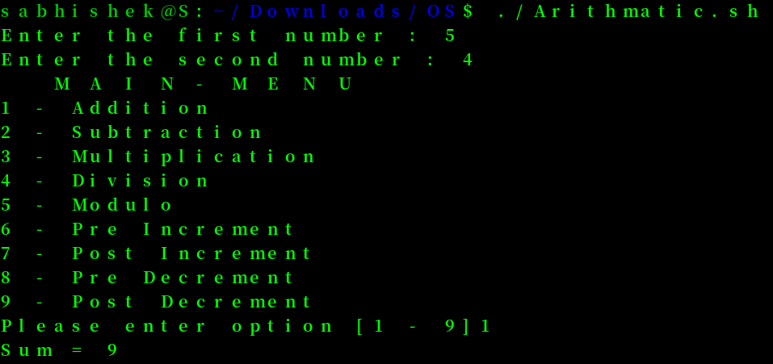

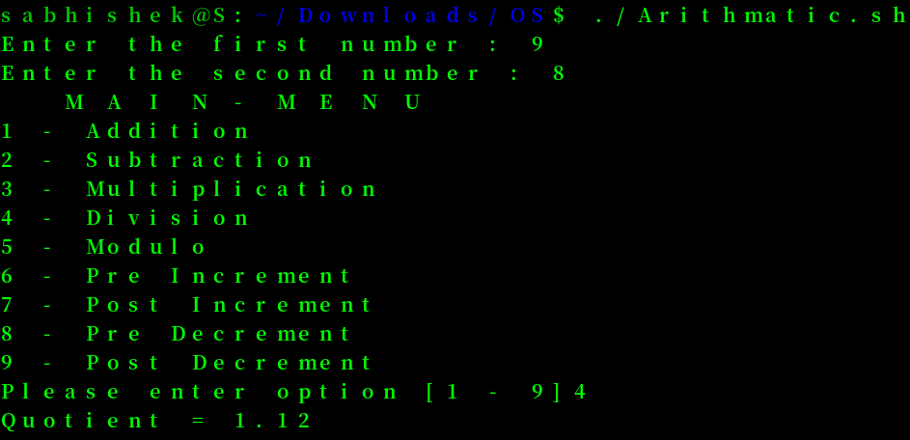

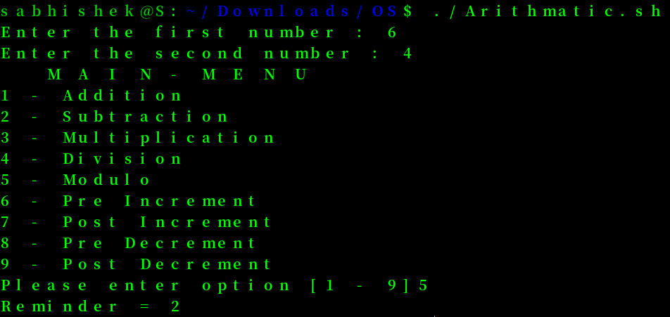

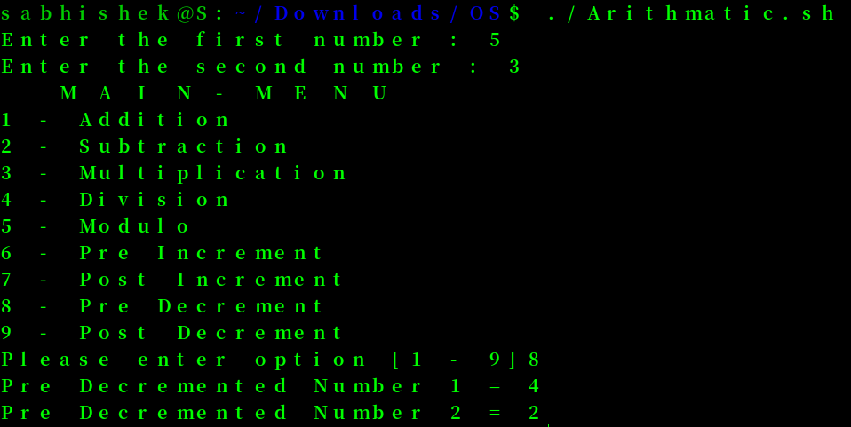

**4. Write two separate shell scripts to find the factorial of a number using while statement and for statement.**

**#!/bin/bash**

**i=1**

**sum=1**

**read -p "Enter the Number : " num**

**num=$(( num+1 ))**

**while [ $i -lt $num ]**

**do**

**sum=$(( sum*i ))**

**i=$(( i+1 ))**

**done**

**echo "Factorial : "$sum**

**#!/bin/bash**

**sum=1**

**read -p "Enter the Number : " num**

**for ((i=1; i<=num; i++ ))**

**do**

**sum=$(( sum*i ))**

**done**

**echo "Factorial : "$sum**

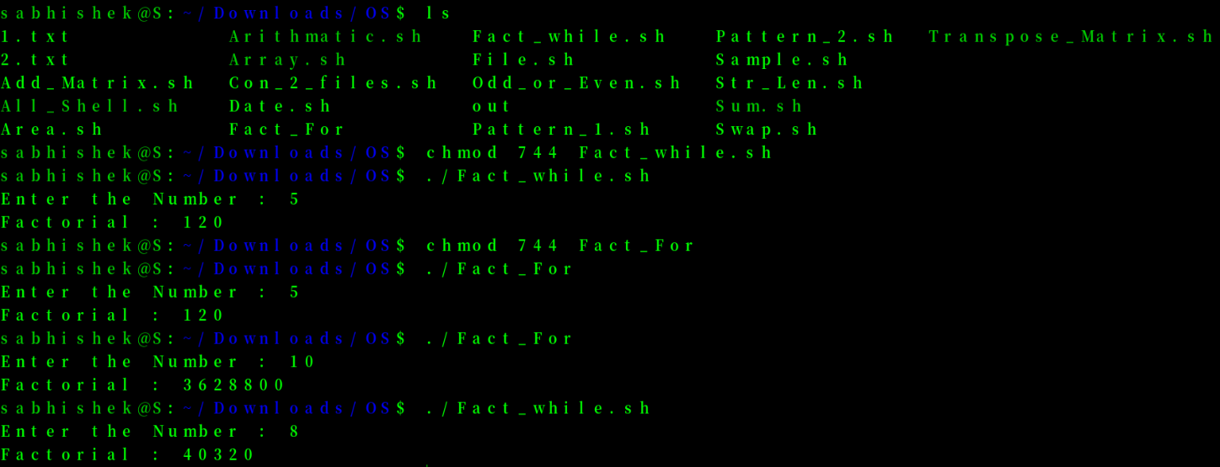

**5. Given a file of numbers (one number per line), write a shell script that will find the lowest and highest number.**

**#!/bin/bash**

**read -p "Enter the File Name : " file**

**echo "Highest : "$(grep [0-9] $file | sort -g | tail -1)**

**echo "Lowest : "$(grep [0-9] $file | sort -g | head -1)**

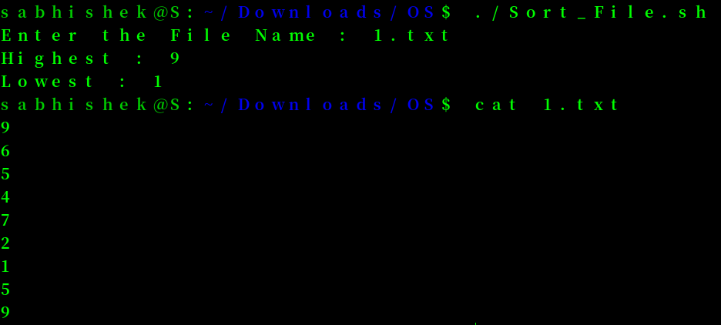

**6. Write a shell program to read n numbers into an array and display the average of them.**

**#!/bin/bash**

**declare -a arr**

**read -p "Enter the number of Elements in the Array : " count**

**sum=0**

**for(( i = 0 ; i < $count ; i++))**

**do**

**read -p "Enter the Element : " x**

**arr[$i]="$x"**

**sum=$((sum+x))**

**done**

**echo -e "Array = ${arr[@]}"**

**ave=$(echo "scale=2;($sum)/$count"| bc)**

**echo "Average = "$ave**

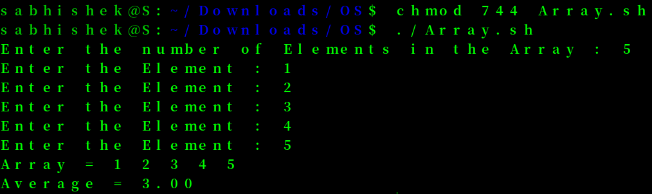



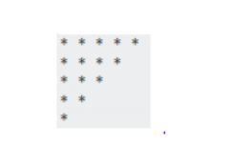

**#!/bin/bash**

**for(( i = 5 ; i > 0 ; i--))**

**do**

**for(( j = 0 ; j < $i ; j++))**

**do**

**echo -n "*"**

**done**

**echo ""**

**done**

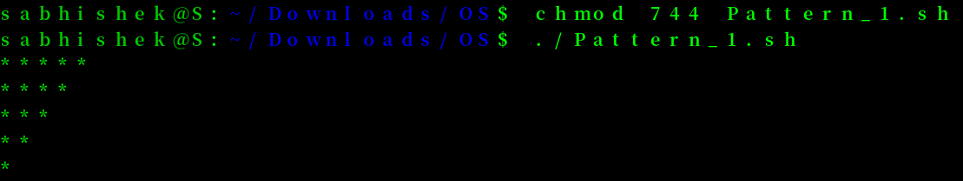



**#!/bin/bash**

**space=4**

**star=1**

**for(( i = 1 ; i <= 5 ; i++))**

**do**

**for((j=0;j<space;j++))**

**do**

**echo -n " "**

**done**

**space=$(( space-1 ))**

**for((j=0;j<$star;j++))**

**do**

**echo -n "*"**

**done**

**star=$(( star+2 ))**

**echo ""**

**done**

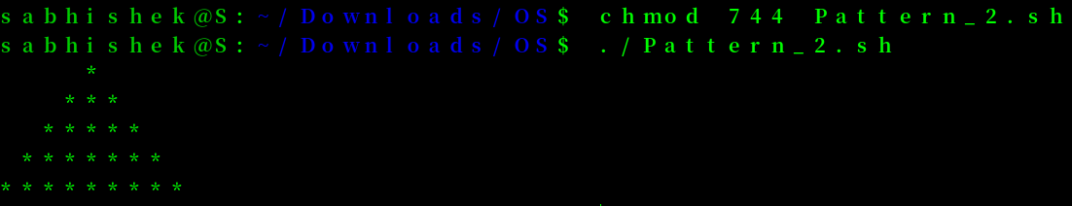

**8. Write a shell program to read two matrices, add them and print the output matrix.**

**#!/bin/bash**

**read -p "Enter the No of Rows : " row**

**read -p "Enter the No of Columns : " col**

**echo "Matrix 1"**

**for((i=1;i<=$row;i++))**

**do**

**for((j=1;j<=$col;j++))**

**do**

**read -p "Enter the Element : " arr1[$i$j]**

**done**

**done**

**echo "Matrix 2"**

**for((i=1;i<=$row;i++))**

**do**

**for((j=1;j<=$col;j++))**

**do**

**read -p "Enter the Element : " arr2[$i$j]**

**done**

**done**

**echo "Matrix 1"**

**for((i=1;i<=$row;i++))**

**do**

**for((j=1;j<=$col;j++))**

**do**

**echo -n ${arr1[$i$j]}**

**echo -n " "**

**done**

**echo ""**

**done**

**echo "Matrix 2"**

**for((i=1;i<=$row;i++))**

**do**

**for((j=1;j<=$col;j++))**

**do**

**echo -n ${arr2[$i$j]}**

**echo -n " "**

**done**

**echo ""**

**done**

**for((i=1;i<=$row;i++))**

**do**

**for((j=1;j<=$col;j++))**

**do**

**arr3[$i$j]=`expr ${arr1[$i$j]} + ${arr2[$i$j]}`**

**done**

**done**

**echo "Addition of Matrices is : "**

**for((i=1;i<=$row;i++))**

**do**

**for((j=1;j<=$col;j++))**

**do**

**echo -n ${arr3[$i$j]}**

**echo -n " "**

**done**

**echo ""**

**done**

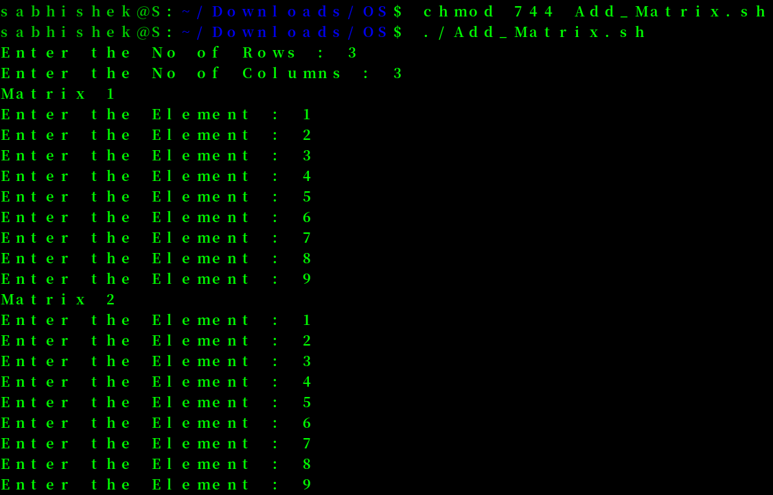

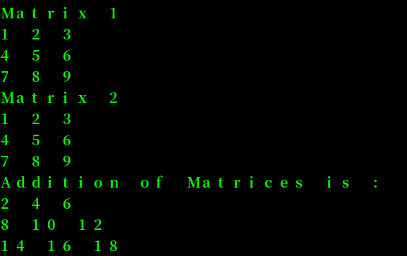

**9. Write a program to read a matrix and print the transpose of it.**

**#!/bin/bash**

**read -p "Enter the No of Rows : " row**

**read -p "Enter the No of Columns : " col**

**echo "Matrix 1"**

**for((i=1;i<=$row;i++))**

**do**

**for((j=1;j<=$col;j++))**

**do**

**read -p "Enter the Element : " arr[$i$j]**

**done**

**done**

**echo "Original Matrix :"**

**for((i=1;i<=$row;i++))**

**do**

**for((j=1;j<=$col;j++))**

**do**

**trans[$j$i]=$((arr[$i$j]))**

**echo -n ${arr[$i$j]}**

**echo -n " "**

**done**

**echo ""**

**done**

**echo "Transpose Matrix :"**

**for((i=1;i<=$row;i++))**

**do**

**for((j=1;j<=$col;j++))**

**do**

**echo -n ${trans[$i$j]}**

**echo -n " "**

**done**

**echo ""**

**done**

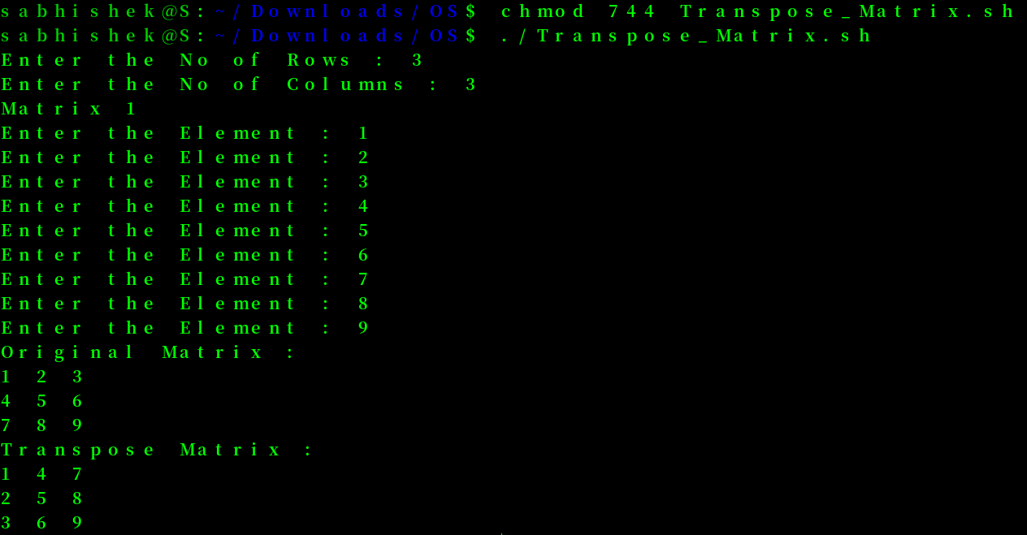

**ThankYou !!**